1. Lvl 3

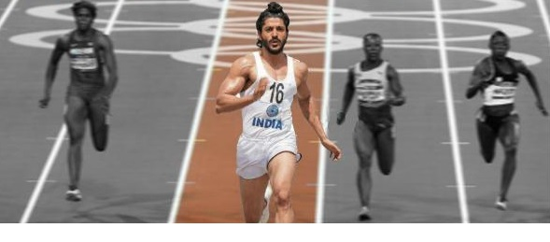



WHO AM I?

Ans: michaelphelps.

Flying sikh nick fish flying fish

1. Lvl 1





WHO MADE THIS?

Ans: bruce lee the way of the dragon

3. What did I born as? (lvl3)

black berry first product

Ans: inter@ctivepager900

1. wromg

C:\Users\student64\AppData\Local\Microsoft\Windows\Temporary Internet Files\Content.Word\002 - Copy.jpg tiny

 small

 big

Just Make It Great!

Ans: pizzahut

5.





grace space pace

What Do I Look Like?

Ans: jaguar (lvl 2, lvl 3)

6. wromh





  
 play + beautiful =🡺 fifa 16

sonam and that place shows beautiful

 fifa 16 has women team added unlike fifa 15

FIND INITIALS OF ME and WRITE IT IN ALPHABETICAL ORDER!

Ans: ABCCEFGIMSSU

7.

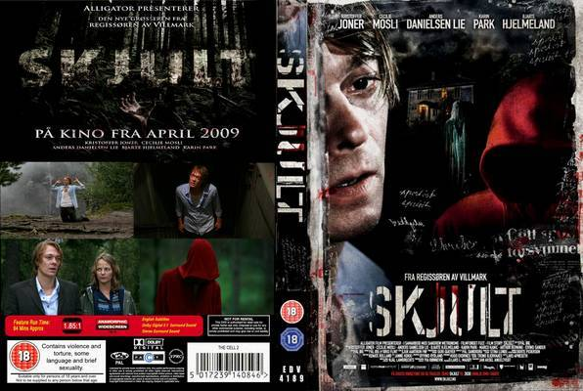

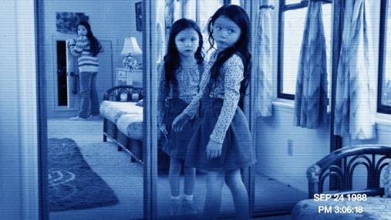

https://youtu.be/Bi57_AYFVTQ

Ans: christophernolan lvl 5

8.

9  

.

An

Ans: robertdowneyjr lvl4

9.Where did I born?



Answer- harvard lvl2

10. I am different at different times. What am I?

Ans => Ben10 lvl1

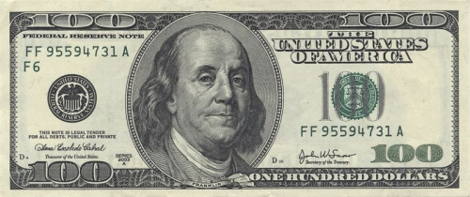

11. Now, games are rocked by black power. The first target is the answer. (wromg)

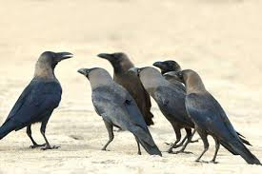

Anwser - **Betty Lou Jensen** and **David Faraday**

Sol: 1968+serial +murder = Zodiac Killer

12.

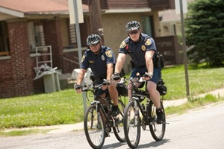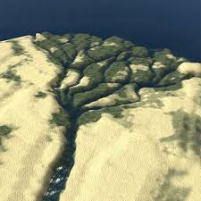

Answer - [Brandon Jay McLaren](https://en.wikipedia.org/wiki/Brandon_Jay_McLaren)

Sol. – Space Patrol Delta(S.P.D.) ka red ranger ka real name

13. I have random stars but similar to me I have a brother who has circle of stars. Identify my brother.

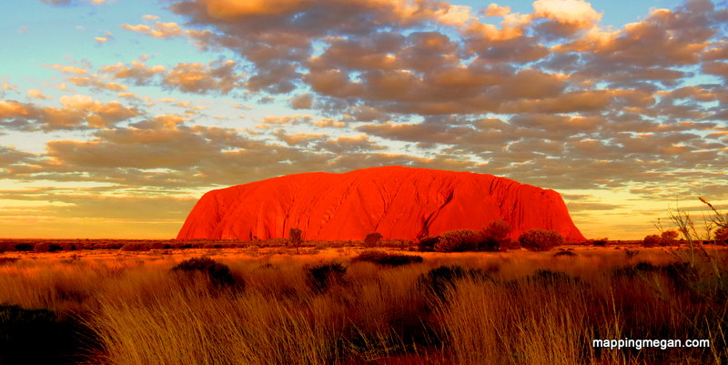

Anwser – Cook Islands (add photo lvl4)

Sol. – Australian flag is similar to cook island but has a little difference.

14. where am I located?



Ans- south africa (lvl3)

Sol-alien +language+pumpkin = district 9

15. Who made me?



Ans - [Minh Le](https://www.google.co.in/search?biw=1745&bih=881&q=minh+le&stick=H4sIAAAAAAAAAOPgE-LQz9U3MDI2TlbiBLFMLNKTKrSUs5Ot9JPL0vWT83MLSktSi-LLMlNS89MTc1OtUlKLM9PzUosA86pG9DwAAAA&sa=X&ved=0CKMBEJsTKAEwF2oVChMI8farktaryAIVx3COCh1SHAld), [Jess Cliffe](https://www.google.co.in/search?biw=1745&bih=881&q=jess+cliffe&stick=H4sIAAAAAAAAAOPgE-LQz9U3MDI2TlbiBLHMzEuMjLSUs5Ot9JPL0vWT83MLSktSi-LLMlNS89MTc1OtUlKLM9PzUosAmqCnWjwAAAA&sa=X&ved=0CKQBEJsTKAIwF2oVChMI8farktaryAIVx3COCh1SHAld)

Sol. – Counter Strike (lvl 1)

16. Humans can make great machines. Who is my older bearer? (change)

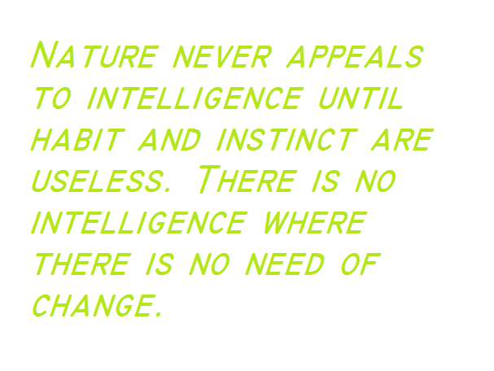

Ans. – Terminator 2

Sol. – Time Machine used in movie ‘Contact’ was to be used in ‘terminator 2’.

17. Who am I? (lvl3)



Ans. – Asus

Sol. – In search of incredible

18. wromg



